Model Exam
MLA0214 – Fundamentals of Machine Learning for Motlbot
Name: Siva Dakshitha Reg no:192425395

Experiment-4(COMPARISON)
Aim
To compare the performance of Naïve Bayes, Logistic Regression, and KNN algorithms for spam email classification and identify the best model.
Algorithm
- Prepare dataset with features (Offer, Link) and label (Spam).
- Convert categorical values (Yes/No) into numerical form (1/0).
- Initialize three models: Naïve Bayes, Logistic Regression, and KNN.
- Train all models using the dataset.
- Test the models using sample input.
- Calculate accuracy of each model.
- Compare accuracies and select the best-performing algorithm.
Code
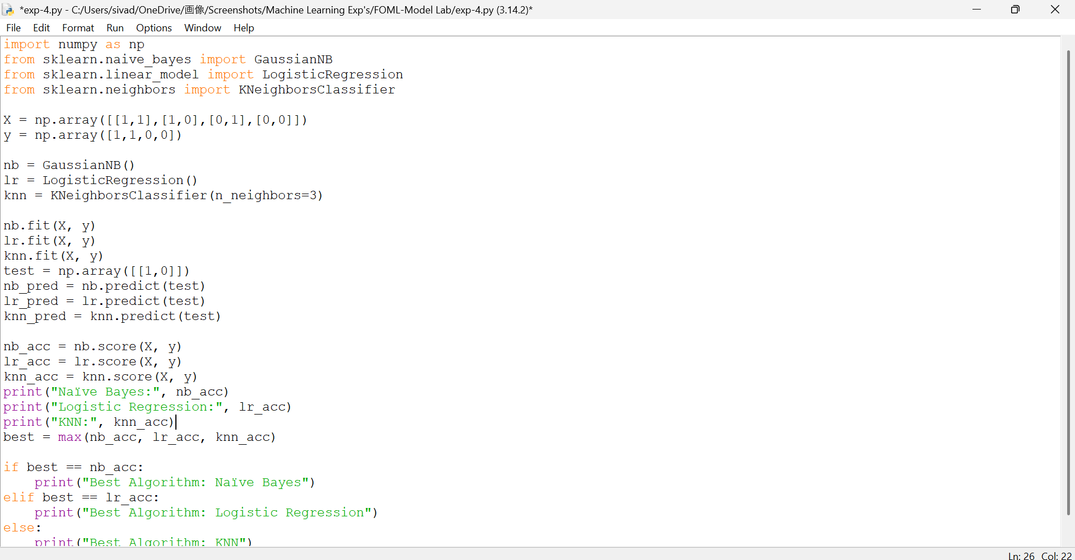

Output
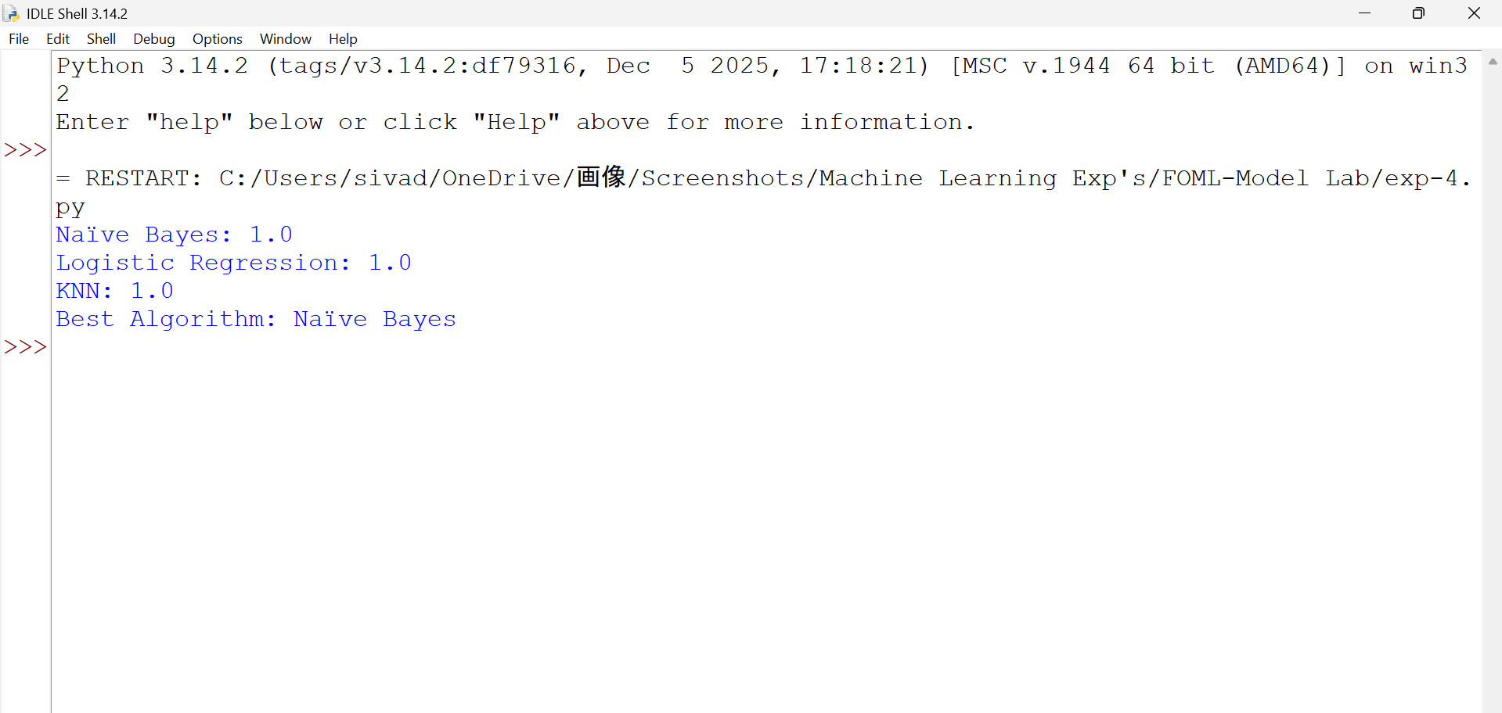

Result
The comparison of Naïve Bayes, Logistic Regression, and KNN algorithms was successfully implemented, and Naïve Bayes was found to give the best performance among all models.

